Resolve To Be Kind, Not Right
February 22nd, 2021

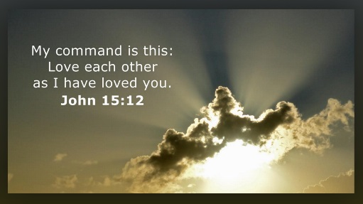
Lord, please help us to see what is behind conflicts, and not assign motives of hostility to others. I know the enemy has many situations set up just to break the bonds of brotherly love. Help us to recognize these traps and not play into them. Amen.

Mother Clare began, “A certain situation came about many days ago where I felt sharp replies in a conversation that I didn’t think was antagonistic. However, the other person did and I was startled by the harshness of their answers. To anyone in the world it wouldn’t be bothersome, but in a family or community setting it was inappropriate and felt like a personal attack. I wrestled with it, pushing out judgment and seeking the Lord’s perspective.

“Our Lady came to my rescue to help me understand that it was not rejection or an attack, but a way of operating in the world that was no longer necessary in this environment. So, I prayed and let it go.”

Then the Blessed Mother began to speak, “My Children, why have you allowed enmity to enter in? Do you not know that you are weakening your very selves? When you have hostility to those who care deeply for you, you are cutting off your nose to spite your face.

“I long for you to be gentle and forgiving with one another and not take offense so easily. Satan would have you imagine that the person sitting next to you or across from you is your adversary and they must be conquered and put in their place.

“This is not what I see. I see demons dropping ugly thoughts into your minds so you will respond defensively, lash out, freeze up or run. How very sad it is to see friends respond to demonic prodding’s against one another. How I grieve for you all. Have you forgotten that you love one another, you need one another, you are all in the Lord’s army and the enemy wants to disband it so he can have free reign over souls, taking them to Hell?

“Do you not know the tenderness in your hearts you hold for one another? Tenderness forged at such a great price, the very blood of my Son. He has brought you together for His purposes and He desperately needs you to show charity to one another, to yield to one another, not to blow up or grow cold, but acknowledge your imperfections and ask for forgiveness. You only hurt yourselves on a deeper level when you entertain attitudes against one another. Many times, it is a simple matter of miscommunication which you do not have to interpret as hostility, that could easily be untangled without hard feelings by just embracing the other person’s viewpoint.

“This is what I want you to do in the future, inquire of the other person who has caused you consternation, “What are you thinking here, I don’t understand why you seem upset?” This would be very pleasing to me and very pleasing to Heaven. But listening to the ugly and divisive suggestions of the enemy is no way for you to behave. Love one another, as He has loved you, as I have loved you. And always think the very best about each other, until proven conclusively that they had ill intent towards you. This is the safest way to proceed.

“Little children, love one another, take the time to understand one another. Be quick to apologize, not quick to judge. Forgive one another, because your sins are pouring out behind you like sand. Avoid self-righteousness with all your hearts, it is a relationship crusher. You have many battles ahead of you and it could be so very easy to get you on a downward spiral before you do what you have come here to accomplish.

“Please be on guard and watch yourselves carefully, relationships especially with parents can bleed over and be projected on others, always, do a reality check when you start to form judgments and do not assign motives to one another. I will help you to love, to understand, to be yielding, these are golden qualities of a disciple of Christ.”

“Thank you, Mother, please help me to have the right heart and mind, being more gentle and understanding. I know it is not important to be right, but to be kind. Help me not to be defensive, but to understand others and be supportive of their needs.”

“This prayer I will answer,” Blessed Mother continued, “Be mindful to recognize what voice is influencing your perceptions of others. Many, many times, it is the enemy. If you are careful, you will avoid injury to others. Ask for the grace not to assign motives. This prayer I will also answer. Go now to love and serve one another and your God.” Amen!

